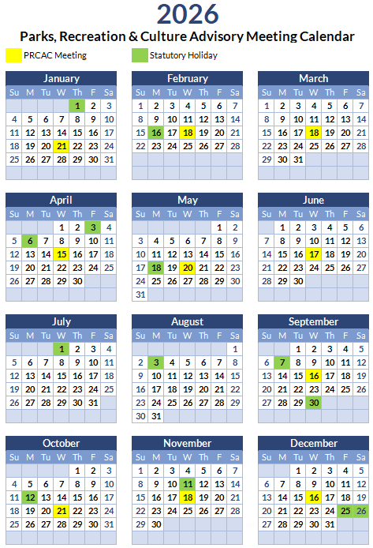

- Regular PRCAC Meeting begin at 7:00pm on the third Wednesday of each month
(note: no meeting July and August). Schedule is subject to change based on agenda items.
- Meetings are held at the Frank Jameson Community Centre at 810 6th Avenue or as otherwise posted.


